R. Reports Menu: 1. Asset Report

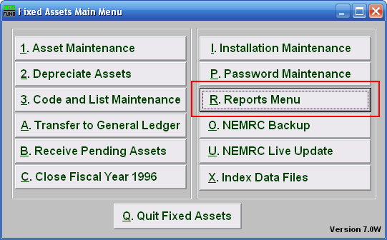
Click on “R. Reports Menu” from the Main Menu and the following window will appear:

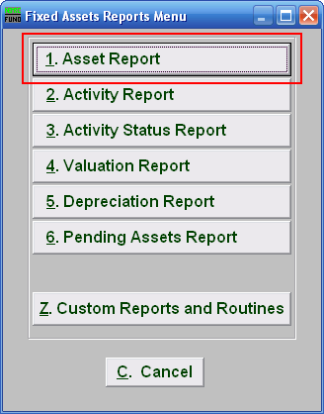
Click on “1. Asset Report” from the Reports Menu and the following window will appear:
Asset Report
Data ranges and grouping

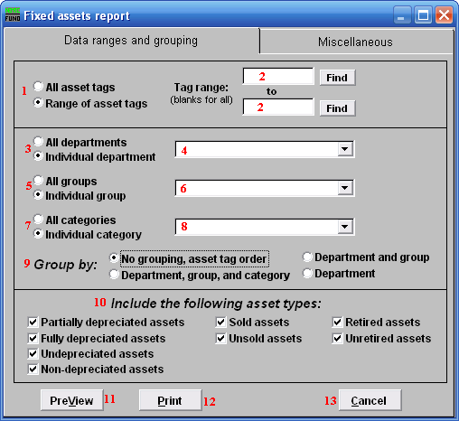
- All asset tags OR Range of asset tags: Select whether you want the report to be for All asset tags or a Range of asset tags.

- Tag range: If you chose Range of asset tags, this field will become available for you to enter the Asset tag or you may click on the “Find” button and select from the drop down menu.

- All departments OR Individual department: Select whether you want the report to be for All departments or an Individual department.

- Selector: If you chose Individual department, click on the drop down arrow and select from the table.

- All groups OR Individual group: Select whether you want the report to be for All groups or an Individual group.

- Selector: If you chose Individual group, click on the drop down arrow and select from the table.

- All categories Or Individual category: Select whether you want the report to be for All categories or an Individual category.

- Selector: If you chose Individual category, click on the drop down arrow and select from the table.

- Group by: Select how you would like the report to group the assets by.

- Include the following asset type: Select the type of assets you would like the report to include.

- PreView: Click this button to preview. Refer to GENERAL PREVIEW for more information.

- Print: Click this button to print. Refer to GENERAL PRINTING for more information.

- Cancel: Click “Cancel” to cancel and return to the previous screen.

Miscellaneous
Click on the “Miscellaneous” tab and the following window will appear:

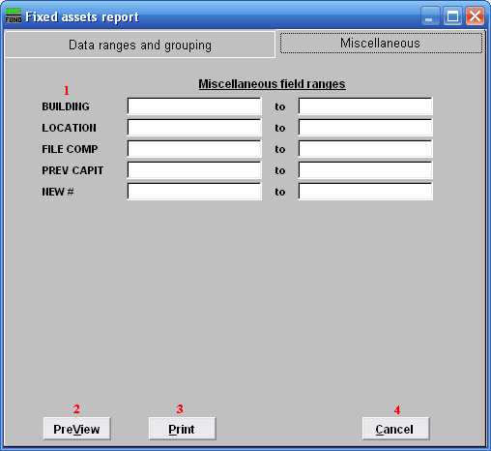
- Miscellaneous field ranges: These fields are user defined in “I. Installation” from the Main Menu.

- PreView: Click this button to preview. Refer to GENERAL PREVIEW for more information.

- Print: Click this button to print. Refer to GENERAL PRINTING for more information.

- Cancel: Click “Cancel” to cancel and return to the previous screen.

